Ain Shams University  International Credit Hours  Faculty of Engineering | 

CSE241: Object-Oriented Computer Programming

Desktop Hotel Reservation System

Milestone 2

Prepared By (Group Number: 023)
- Norhan Mohamed Fawzy ElZahaby - 25p0329
- Youstina Nagy Atta - 25p0324
- Omar Ahmed ElSayed ElGharably - 25p0142
- Seif Ahmed Mahrous - 25p0395
- Rawan Hamada Emam Elsayed – 25p0123

Course Details
- Instructor: Dr. Mahmoud Khalil
- Eng. Mario
- Eng. Mazen Tarek

- Academic Semester/Year : Spring 2026

Submission Date: 9/5/2025

Table of Contents
- Introduction and Overview
- Changes and Enhancements from Milestone 1
- JavaFX GUI Architecture
- Screen-by-Screen Documentation
- FXML Files and MVC Separation
- CSS Styling
- Multi-threading Implementation
- Networking: Java Sockets and Live Chat
- Database Integration
- New and Modified Classes
- Design Decisions
- Test Cases
- Known Limitations
- Team Contributions

1. Introduction and Overview
Milestone 2 builds on the backend established in Milestone 1 by adding a complete graphical user interface built entirely in JavaFX, real-time background operations using Java threads, client-server live chat via Java Sockets, and persistent storage using a MySQL database accessed through JDBC. The console-based test harness from Milestone 1 is retained in the test class but is no longer the primary entry point; the application now launches through testGUI, which extends javafx.application.Application.
The system models a luxury hotel called Kempinski and supports three distinct user roles: Guest, Receptionist, and Admin. Each role has its own dashboard, sidebar navigation, and set of screens. All screens share a consistent visual identity defined in a single style.css file.

2. Changes and Enhancements from Milestone 1
Several structural additions were made to the backend to support the GUI and new features.
The User class gained a loggedIn boolean flag and an email field. The email field required updates to all constructors across User, Staff, Admin, Receptionist, and Guest. The Authenticator class gained validateEmail, validateBirthDate, and validateVisaCard methods. The Guest class gained a displayname field to separate the visible name from the login username, an overDue flag used to force guests with overdue stays to the checkout screen, and the pay method was extended to accept a VisaCard parameter. The Invoice class gained a VisaCard field to support credit card payment recording.
The HotelDataBase class was significantly expanded. All six lists were changed from ArrayList to Collections.synchronizedList-wrapped lists to support concurrent access from background threads. Several new query methods were added: searchUserByEmail, getGuestPendingReservation, receptionistGetGuestPendingReservation, filterRoomsByPrice, filterRoomsByAmenities, filterRoomsByRoomType, findRoomType, findAmenity, findRoom, and getUsers. The static initialiser block was replaced by an explicit seedDefaultData method called conditionally from the application entry point.
The Reservation class gained a specialRequests field, allowing guests to attach notes when booking. The Room class gained a calcTotal helper method used by both the checkout screen and the reservations list.
Three entirely new infrastructure classes were introduced: AppSession, EventBus, DataBaseManager, ChatServer, ChatClient, ChatMessage, ReservationContext, VisaCard, and JumpInTime. These are described in detail in section 10.

3. JavaFX GUI Architecture
The application follows a modified MVC pattern. Each FXML file is the View; each *Controller Java class is the Controller; the existing domain classes from Milestone 1 serve as the Model.
Session propagation. Rather than passing data through constructor parameters or static variables, every controller implements the SessionController interface, which declares a single method initSession(AppSession session). When the application navigates to a new screen, MainController.navigate loads the FXML, checks whether the resulting controller implements SessionController, and if so calls initSession with the shared AppSession stored in the Stage's userData slot. This means every controller has access to the currently logged-in user, the reservation context, and any selected entities without any direct coupling between controllers.
Navigation. MainController provides two static helpers: navigate(ActionEvent, String) which pushes the target file onto a history stack and then loads it, and load(ActionEvent, String) which loads without affecting the history. The back button calls back(ActionEvent) which pops the history and reloads the previous entry.
Dual-window startup. The testGUI class opens two independent Stage windows, each holding its own AppSession. This allows two different users to be logged in simultaneously in the same JVM, which is particularly useful for testing the live chat feature where one window acts as the guest and the other as the receptionist. Both windows share the same static HotelDataBase lists, so changes made in one window are reflected in the other via the EventBus.

4. Screen-by-Screen Documentation

4.1 Main Menu
The entry screen displays a full-bleed hotel background image with a navy overlay, the Kempinski wordmark, and two buttons: Sign In and Register. It is the only screen that does not require a session.

4.2 Login Screen
Contains a username field, a password field with a show/hide toggle, an error label, a Forget Password hyperlink, and a Back button. On submission, User.Login is called. If successful, the controller checks the user type and navigates to the appropriate dashboard. A guard prevents a user who is already logged in from logging in again.

4.3 Register Screen
A scrollable form with fields for display name, username, email, password, gender, date of birth, address, initial balance, preferred floor, and preferred view. Every field is validated inline using Authenticator methods before Guest.Register is called. Decimal and integer input filters are applied to the balance and floor fields via TextFormatter to prevent non-numeric input at the keyboard level.

4.4 Forget Password Screen
Allows a user to reset their password by providing their username, registered email, and a new password confirmed twice. Both password fields support show/hide toggles. The screen does not require the user to be logged in.

4.5 Guest Dashboard
A simple welcome screen showing the guest's display name. It serves as the landing page after login and hosts the shared navigation bar and guest sidebar.

4.6 Guest Profile
Displays the guest's full information: display name, username, gender, date of birth, balance, and address in read-only styled fields. An avatar circle shows the first initial of the display name.

4.7 View Rooms
Shows all rooms in the hotel as cards. Each card displays the room type, view, room number, floor, capacity, nightly rate, and included amenities. A collapsible filter bar provides four filter modes: by maximum price using a slider, by amenities using toggle tags, by room type using toggle tags, and by the guest's stored preferences. Rooms subscribe to EventBus events for room changes, amenity changes, and room type changes so the list refreshes automatically if an admin modifies the inventory in another window.

4.8 Make Reservation
Presents check-in and check-out date pickers. On clicking Search, a background Task is launched that fetches available rooms from HotelDataBase.getAvailableRooms. While the task runs a ProgressIndicator spinner is shown in the room container. When the task completes on the JavaFX thread, the matching rooms are rendered as cards identical to View Rooms, each with a Reserve This Room button. Clicking the button stores the selected room and dates in ReservationContext and navigates to the Reservation Form.

4.9 Reservation Form
A two-panel screen. The left panel contains date pickers that are pre-populated from ReservationContext, a special requests text area, and a Confirm Reservation button. The right panel is a navy summary card showing total nights, room type, price per night, amenity list, and a dynamically computed total cost. Date changes immediately recompute the summary. On confirmation, Guest.makeReservation is called and the screen navigates to View Reservations.

4.10 View Reservations
Lists all reservations for the current guest regardless of status. Each card shows the status as a colour-coded badge (gold for pending, green for confirmed, grey for completed, red for cancelled, teal for awaiting confirmation). Pending reservations show a Request Cancellation button. Clicking it reveals Confirm and Abort buttons; confirming calls Guest.cancelReservation. The list subscribes to RESERVATION_CHANGED and TIME_JUMPED events.

4.11 Checkout / Payment Screen
Attempts to call Guest.checkOut on load. If no confirmed reservations are due, an error panel is shown with an explanation. If successful, a styled invoice paper is rendered showing the hotel letterhead, guest name, invoice number, date, itemised line rows for each reservation, amenity charges, and a late-payment fee row (20% of total) when the checkout date has passed the current simulated date. The payment section provides three radio buttons: Credit Card, Account Balance (Online), and Cash. Selecting Credit Card reveals a form for card holder name, card number, expiry date, and CVV; a Verify Card Details button validates the input using Authenticator.validateVisaCard before the final payment is allowed. Account Balance shows the guest's current balance. Cash shows front-desk instructions. The Complete Check-Out button calls Guest.pay with the appropriate method. If the guest has an overdue stay the sidebar disables all other navigation options and forces them to this screen first.

4.12 Guest Live Chat
Connects to the ChatServer on load using ChatClient. A GUEST_REQUEST message is broadcast; the server adds the guest to the waiting list and notifies all online receptionists. When a receptionist claims the guest, a CLAIM message arrives and the chat becomes active. Messages typed before a receptionist joins are queued and flushed on claim. The chat renders messages in styled bubbles, right-aligned for sent messages and left-aligned for received messages. System messages appear centred in italic gold text.

4.13 Admin Dashboard
Displays four KPI cards: Total Users, Active Bookings, Total Revenue, and Available Rooms. All values are computed live from HotelDataBase and refresh automatically in response to RESERVATION_CHANGED and USER_CHANGED events.

4.14 Admin Rooms
Shows all rooms as cards with a collapsible inline add/edit form on the right. The form is built programmatically rather than in FXML. Room number, floor, view, room type, and amenities (clickable toggle tags) are all editable. Edit and Delete buttons are disabled on rooms with active reservations. Deletion requires confirmation through a styled Alert dialog with a navy background matching the application theme.

4.15 Admin Room Types
Displays room types as card tiles in a FlowPane. Each card shows the room type icon (chosen based on the size name), the name, capacity chip, base price, and a count of how many rooms use that type. An inline form for add/edit slides in from the top of the content area.

4.16 Admin Amenities
Identical layout to Room Types but for amenities. An icon is assigned to each amenity by keyword matching on the name. Edit and Delete actions are locked when the amenity is in use in an active reservation.

4.17 Admin Receptionists
Lists all receptionists with a card showing username, email, date of birth, gender, and working hours. An inline Add Receptionist form includes a password field with show/hide toggle, email, date of birth, gender combo, and working hours. Calling Admin.addReceptionists persists the new receptionist to the database asynchronously.

4.18 Admin Guests
Read-only view of all registered guests, including balance chips and a reservation summary count showing how many reservations are active. A search field filters by display name or username in real-time using a listener on the text property.

4.19 Admin Reservations
Lists all reservations with a status filter ComboBox. Status counts (total, pending, confirmed, completed) are shown in a navy stats strip.

4.20 Receptionist Dashboard
Shows three KPI counters: check-ins today, check-outs today, and total reservations. Values refresh on RESERVATION_CHANGED and TIME_JUMPED events.

4.21 Receptionist Check-In
Lists guests who have a PENDING reservation with a check-in date matching JumpInTime.now. Each card shows the guest's username, email, and all pending reservations for today with room details and night count. A Confirm Check-In button calls Receptionist.checkIn, which transitions the reservations to CONFIRMED.

4.22 Receptionist Check-Out
Lists guests whose invoices contain a reservation in AWAITING_CONFIRMATION status with a check-out date on or before today. A Confirm Check-Out button calls Receptionist.checkOut, setting those reservations to COMPLETED.

4.23 Receptionist All Reservations
Read-only log of every reservation in the system, each card showing guest name, room details, dates, total cost, amenities, and status badge.

4.24 Receptionist Guests
Identical in functionality to the Admin Guests screen.

4.25 Receptionist Rooms
Read-only view of all rooms showing occupancy status (AVAILABLE or OCCUPIED) but without edit or delete controls.

4.26 Receptionist Live Chat
The receptionist side of the chat system. An incoming guest list at the bottom shows guests who are WAITING (not yet claimed) and guests already claimed by this receptionist. Clicking a WAITING guest sends a CLAIM message; clicking an already-claimed guest switches the active conversation. Each conversation is cached locally so switching between guests does not lose message history within the session. Messages are typed in the input bar and sent with the Send button or Enter key.

4.27 Jump In Time
An administrative tool available to receptionists styled as a science-fiction temporal control console. It uses animated elements: a scanline that sweeps down the panel, a pulsing green dot, and a glowing arrow between the current and target date panels. A DatePicker lets the receptionist select a future date. The temporal delta is computed and displayed in the readout strip. Clicking Execute Temporal Jump updates JumpInTime.now, fires RESERVATION_CHANGED and TIME_JUMPED events so all subscribed screens refresh, and plays a brief flash and scale animation before resetting the form. The button is disabled and a red error message appears if a past or same date is selected. The interface rejects backwards jumps because the system does not support reversing confirmed check-ins.

4.28 Staff Profile
A shared profile screen for both Admin and Receptionist users, displaying username, email, gender, date of birth, and working hours. The role label and footer text adapt based on the user type.

5. FXML Files and MVC Separation
The project contains well over twenty FXML files. The following are the primary screens defined in FXML:
Main_Menu.fxml, Login_Menu.fxml, Register_Menu.fxml, Forget_Password.fxml, NavgationBar.fxml, GuestSidebar.fxml, Guest_Dashboard.fxml, Guest_Profile.fxml, ViewRooms.fxml, MakeReservation.fxml, Reservation_Form.fxml, ViewReservations.fxml, CheckOut.fxml, GuestChat.fxml, AdminSidebar.fxml, Admin_Menu.fxml, Admin_Rooms.fxml, AdminRoomTypes.fxml, AdminAmenities.fxml, Admin_Receptionists.fxml, Admin_Guests.fxml, Admin_Reservations.fxml, Receptionistsidebar.fxml, Receptionist_Menu.fxml, ReceptionistCheckIn.fxml, ReceptionistCheckOut.fxml, ReceptionistReservations.fxml, ReceptionistGuests.fxml, Receptionist_Rooms.fxml, ReceptionistChat.fxml, ReceptionistJumpInTime.fxml, Staff_Profile.fxml.
Sidebars (GuestSidebar.fxml, AdminSidebar.fxml, Receptionistsidebar.fxml) and the navigation bar (NavgationBar.fxml) are included as nested FXML components using <fx:include>. Their controllers are injected into the parent controller via fx:id fields annotated with @FXML. The parent controller then calls sidebarController.initSession(session) to propagate the session downward.
This structure means the navigation bar and sidebar are defined once and reused across all screens of their respective roles, satisfying the FXML reuse requirement and enforcing clean separation between structural layout and controller logic.

6. CSS Styling
All visual styling is defined in a single file, style.css, loaded into every scene via the stylesheet attribute on the root AnchorPane of each FXML file as well as programmatically in MainController.navigate.
The colour palette uses three primary colours throughout: navy #0F2160 for headers, sidebars, and primary backgrounds; gold #C9A84C for accents, active states, and call-to-action elements; and warm cream #F0EDE4 as the general background. This palette is consistent with a luxury hotel brand identity.
Notable style classes include .room-card for the standardised card container used across guest, receptionist, and admin room listings; .status-badge combined with .status-pending, .status-confirmed, .status-completed, .status-cancelled, and .status-awaiting_confirmation for colour-coded reservation status indicators; .sidebar-nav-btn and .sidebar-nav-btn-active for sidebar navigation; .invoice-paper and its children for the styled checkout invoice; .sci-* classes for the Jump In Time console's science-fiction aesthetic using a dark background with green phosphor-style text and glow effects; and .chat-bubble-me and .chat-bubble-them for the live chat message bubbles.
The scroll bar styling on .register-scroll replaces the default OS scroll bar with a thin gold-thumbed track consistent with the overall theme.

7. Multi-threading Implementation
Multi-threading is used in three areas of the application.
Background database loading. In testGUI.start, a javafx.concurrent.Task<Void> is launched on a daemon thread named DB-Loader. This thread calls DataBaseManager.loadAll() and updates a status label via task.messageProperty() binding. The JavaFX scene is only switched to the main menu inside task.setOnSucceeded, which runs on the JavaFX Application Thread, ensuring no UI updates happen off-thread.
Asynchronous database writes. DataBaseManager maintains a single-threaded ExecutorService named DB-Writer created with Executors.newSingleThreadExecutor. Every write operation (save room, save user, save reservation, and so on) is submitted via DataBaseManager.runAsync(Runnable). The calling code on the JavaFX thread proceeds immediately without blocking while the write is serialised on the background thread. This prevents the UI from freezing during database operations. Because all writes go through a single-threaded executor, the order of operations is preserved.
Room availability search. In MakeReservationController.search, a Task<ArrayList<Room>> wraps the call to HotelDataBase.getAvailableRooms. A spinner is shown while the task runs on a daemon thread named Room-Search. On success, task.setOnSucceeded calls renderRooms on the JavaFX thread. This prevents the UI from freezing if the availability check involves a large number of reservations.
EventBus and Platform.runLater. The EventBus class maintains a ConcurrentHashMap of listeners. Its fire method iterates the listeners and wraps each call in Platform.runLater, ensuring that UI refreshes triggered by background database writes always execute on the JavaFX Application Thread.

8. Networking: Java Sockets and Live Chat
The live chat feature is implemented using Java Sockets across two classes: ChatServer and ChatClient.
ChatServer runs a ServerSocket on port 9090 in a daemon thread named Chat-Acceptor. When a client connects, a new ClientHandler runnable is created and started on its own daemon thread. The server maintains three shared concurrent data structures: a ConcurrentHashMap<String, ClientHandler> mapping usernames to their handlers; a second ConcurrentHashMap<String, String> mapping guest usernames to the receptionist who has claimed them; and a ConcurrentHashSet<String> of guests who are waiting and unclaimed.
Messages are routed based on their ChatMessage.Type enum. A REGISTER message associates the socket with a username and role. A GUEST_REQUEST message adds the guest to the waiting set and broadcasts an updated guest list to all connected receptionists. A CLAIM message moves a guest from waiting to claimed, notifies the guest, removes them from the waiting set, and broadcasts the updated list. A TEXT message is forwarded directly to the named recipient. A GUEST_LEFT message is sent to the claiming receptionist when a client disconnects unexpectedly.
The guest list broadcast uses a serialised String payload in the format username|state; repeated for each entry, where state is either WAITING or the receptionist's username. This avoids any dependency on Java object serialisation for the list itself.
ChatClient opens a Socket to the server, creates ObjectOutputStream and ObjectInputStream wrappers, and sends a REGISTER message. A daemon listener thread reads incoming ChatMessage objects and calls a registered Consumer<ChatMessage> callback via Platform.runLater. The send method is synchronised to prevent concurrent writes to the output stream. Both GuestChatController and ReceptionistChatController hold a ChatClient instance and connect on initSession.
ChatMessage implements Serializable and carries the message type, sender username, sender display name, recipient username, content string, and a LocalDateTime timestamp.
ChatServer.start is called from testGUI.start before any windows are opened so the server is available by the time either chat screen connects.

9. Database Integration
The DataBaseManager class connects to a MySQL database named hotel_db at localhost:3306. The schema contains eight tables: room_types, amenities, rooms, room_amenities (a junction table), users, reservations, invoices, and invoice_reservations (a junction table). The invoice_reservations table uses an AUTO_INCREMENT surrogate key on invoices that is obtained via Statement.RETURN_GENERATED_KEYS when saving an invoice.
DataBaseManager.loadAll runs at application startup and populates all six HotelDataBase lists from the database. Object references are reconstituted: when loading rooms, findRoomType and findAmenity look up already-loaded objects so that rooms share references to the same RoomType and Amenity instances rather than having duplicates. When loading reservations, searchUserByName and findRoom are used similarly. If the database is unavailable or returns no users, HotelDataBase.seedDefaultData is called as a fallback so the application always starts with usable data.
All write operations use INSERT ... ON DUPLICATE KEY UPDATE where a unique natural key exists (size for room types, name for amenities, room number for rooms, username for users, and the composite key of guest username plus room number plus check-in date for reservations). This means save operations are idempotent and can be retried safely.

10. New and Modified Classes
AppSession holds the shared state for one logged-in user within one window. It stores the current user, a ReservationContext, a selected guest and room for cross-screen passing, a due invoice for the overdue checkout flow, and a Stack<String> for navigation history. Its logout method clears all fields and sets the user's loggedIn flag to false.
EventBus is a static publish-subscribe hub. It maintains a ConcurrentHashMap of CopyOnWriteArrayList listeners keyed by the Event enum. subscribe and unsubscribe manage listeners. fire dispatches all listeners via Platform.runLater. Controllers subscribe in initSession and unsubscribe via a scene-property listener that fires when the scene is set to null (meaning the screen has been replaced), preventing memory leaks from orphaned listeners.
ReservationContext is a simple value object held by AppSession that carries the selected room, check-in date, check-out date, and reservation across the Make Reservation and Reservation Form screens without requiring static state.
SessionController is a one-method interface implemented by every controller. It decouples screen loading from session passing.
JumpInTime is unchanged from Milestone 1 except that it is now also fired as a TIME_JUMPED event via EventBus when the receptionist executes a temporal jump.
VisaCard is a simple POJO holding card holder name, card number, expiry date, and CVV. It is created when the guest verifies card details on the checkout screen and stored in the Invoice for database persistence.
ChatServer, ChatClient, ChatMessage are fully described in section 8.
DataBaseManager is described in section 9.

11. Design Decisions
The decision to use a shared AppSession per window rather than static session variables was driven by the dual-window requirement. With two windows sharing the same JVM and the same static HotelDataBase, any static session state would be overwritten by the second login. Storing the session in the Stage's userData slot keeps each window's session completely independent.
The EventBus was introduced specifically to allow the two windows to observe each other's changes. When the admin adds a room in window one, the room-changed event propagates to window two's View Rooms screen without any direct reference between the two controllers. The CopyOnWriteArrayList backing each event's listener list means that subscribers can unsubscribe during event dispatch without a ConcurrentModificationException.
The decision to keep all database writes on a single-threaded executor rather than a thread pool was deliberate: it eliminates the possibility of interleaved writes corrupting the database state. The tradeoff is that a slow write blocks subsequent writes, but for the scale of this application that is acceptable.
The Jump In Time feature was given its own styled console rather than a plain dialog because the concept of manipulating time is inherently outside normal hotel operations and should feel clearly distinct from the rest of the UI. The science-fiction aesthetic signals to the operator that this is a test or simulation tool, not a real-world function.
The overdue detection logic in MainController.handleOverDue runs on every navigation call for guest users. This means a guest who logs in after their checkout date has passed will be automatically redirected to the checkout screen on their first navigation action. The overDue flag on Guest persists within the session so the redirect only forces the checkout screen once per session, not on every subsequent click.

12. Test Cases
The following scenarios were tested and verified.
Valid guest registration. A new guest registers with all required fields filled correctly. The guest is added to the database and can immediately log in. The admin's guest list refreshes automatically.
Duplicate username rejection. Attempting to register with a username already in the database shows the error "Username already exists" beneath the username field without clearing any other field.
Password too short. Entering a password of eight or fewer characters shows "Password must be longer than 8 characters."
Guest under 17. Entering a date of birth within the past 17 years shows "You must be at least 17 years old to register."
Successful room search. Entering valid check-in and check-out dates and clicking Search shows available rooms after a brief spinner. The spinner disappears and is replaced by room cards.
No available rooms. Selecting dates where all rooms are occupied shows "No Available rooms in this duration."
Check-out date before check-in. Selecting a check-out date earlier than the check-in date shows "Check out date can't be before Check in date."
Reservation creation. Clicking Reserve This Room on any card navigates to the Reservation Form, pre-fills the dates, and shows the correct total. Confirming saves the reservation and navigates to View Reservations where the new card appears with PENDING status.
Reservation cancellation. Clicking Request Cancellation on a PENDING card reveals the Confirm and Abort buttons. Confirming cancels the reservation and the card immediately shows CANCELLED status.
Receptionist check-in. After jumping time to the check-in date, the Check-In screen shows the guest. Confirming changes the reservation to CONFIRMED.
Guest checkout — balance insufficient. When a guest selects Account Balance and their balance is below the invoice total, the system throws "Insufficient balance, please choose another method."
Guest checkout — credit card invalid CVV. Entering a two-digit CVV and clicking Verify shows "Invalid CVV. Must be 3 digits."
Guest checkout — credit card valid. Completing all card fields correctly and verifying allows the Complete Check-Out button to proceed. The invoice is saved to the database.
Late payment fee. Jumping time past a guest's checkout date and then opening the checkout screen shows the 20% late payment fee row in the invoice.
Overdue forced redirect. A guest with a CONFIRMED reservation whose checkout date has passed is redirected to the checkout screen on any navigation attempt. All sidebar buttons are disabled.
Admin adds room. Completing the inline form with a new room number, floor, view, type, and amenities and clicking Save Room adds the card to the grid. The second window's View Rooms screen refreshes automatically via EventBus.
Admin deletes room in use. Attempting to delete a room with an active reservation shows the error "Cannot delete Room X — it has active reservations" and the delete button is visually disabled.
Admin adds receptionist. Completing the Add Receptionist form saves the new receptionist to the database. The receptionist can immediately log in and see their dashboard.
Live chat — guest to receptionist. Guest logs in on window one and navigates to Live Chat. Receptionist logs in on window two and navigates to Receptionist Live Chat. The guest appears in the WAITING list. The receptionist clicks the guest to claim them. Messages typed by either party appear in both windows in real time.
Live chat — pending messages. Guest types a message before any receptionist has claimed them. The message is queued. When the receptionist claims the guest, the queued message is delivered.

13. Known Limitations
The system runs two windows from a single JVM and a single main method. In a production deployment, clients would run as separate processes connecting to a shared server. The current architecture is appropriate for demonstration purposes.
The database credentials are hard-coded in DataBaseManager. In a real deployment these would be read from a configuration file or environment variables.
The chat history within a session is stored in HashMap entries on the ReceptionistChatController. If the receptionist navigates away from the chat screen and returns, the history is lost because a new controller instance is created. The guest's message side has no history persistence at all within a session.
The overdue redirect uses MainController.handleOverDue which iterates all reservations on every navigation call. For a large number of reservations this would become slow; an indexed query would be preferable.
Passwords are stored and compared in plain text. Production systems would use a hashed and salted password store.

14. Team Contributions
All members contributed to integrating their components into the shared codebase via Git, participated in code review.

15.UML Diagram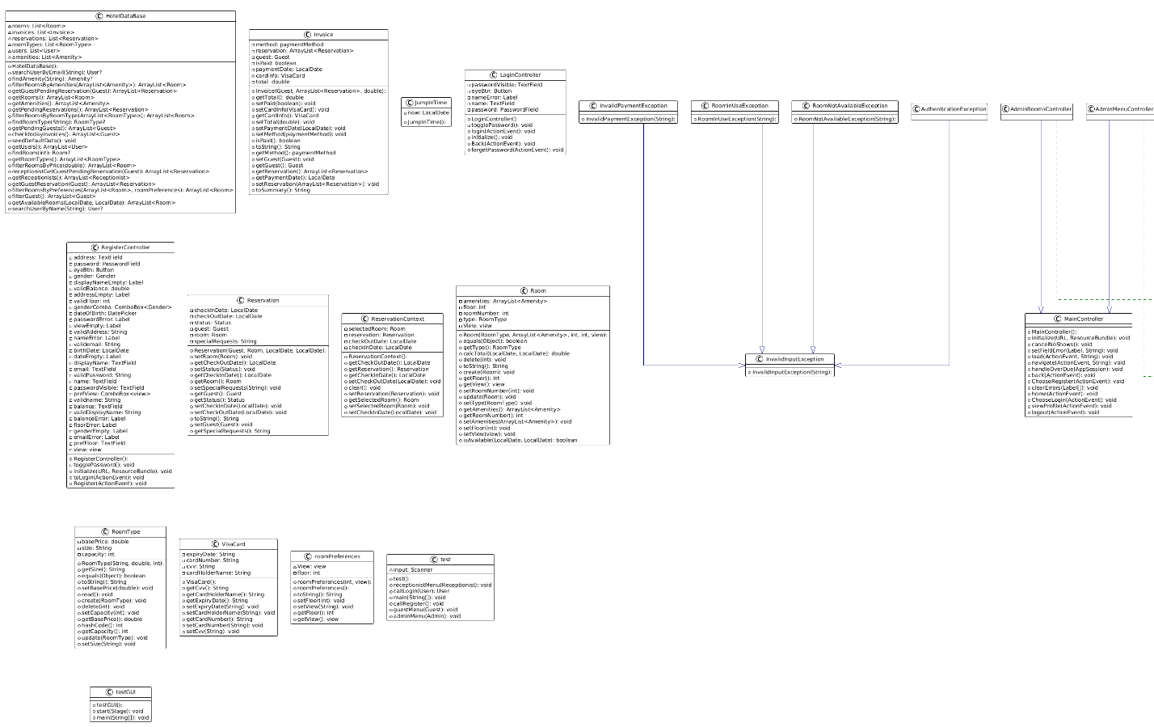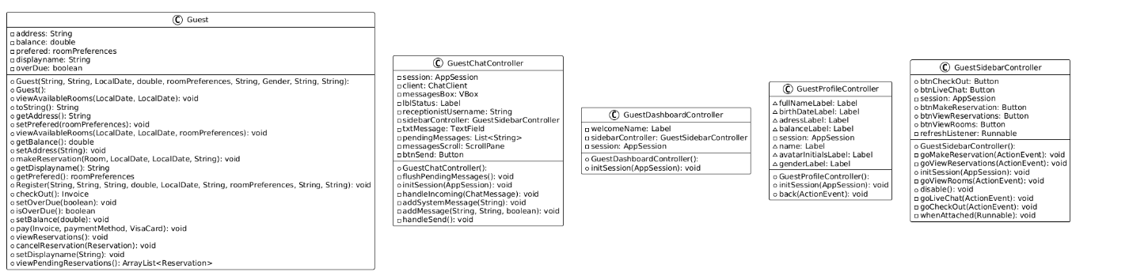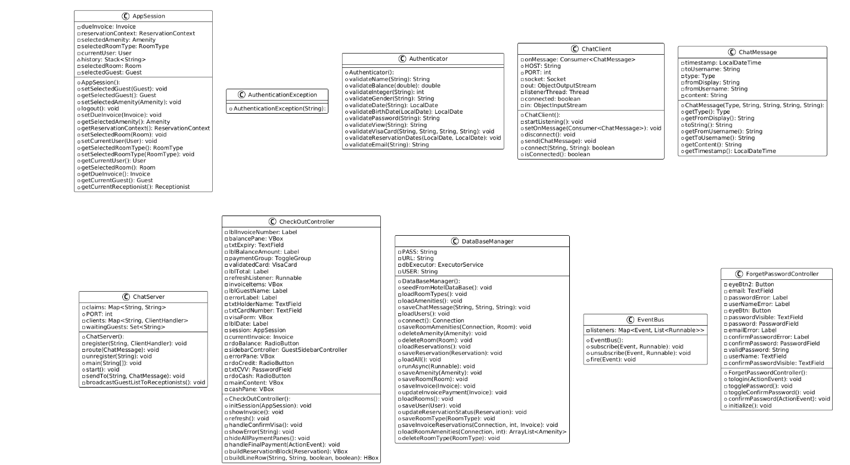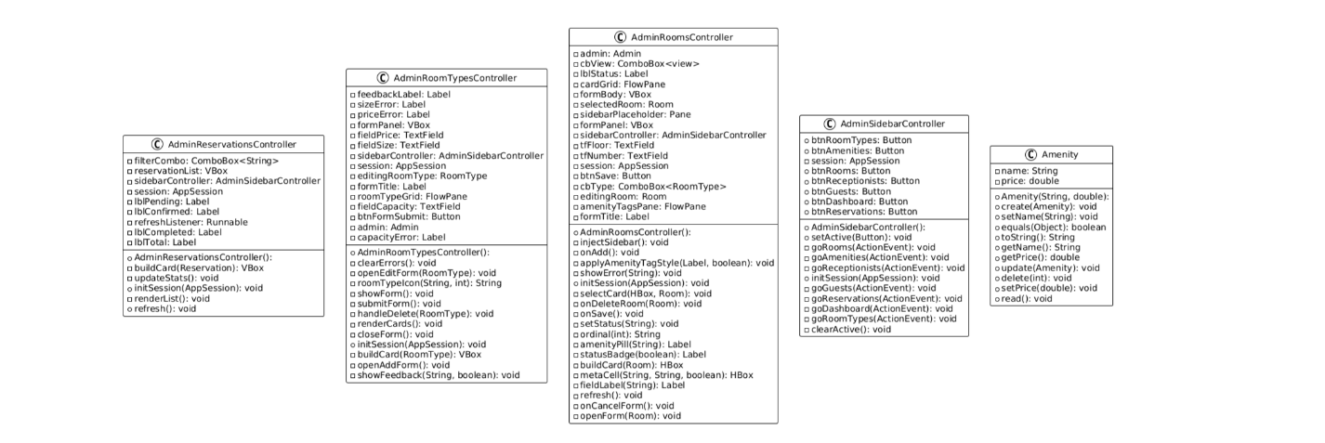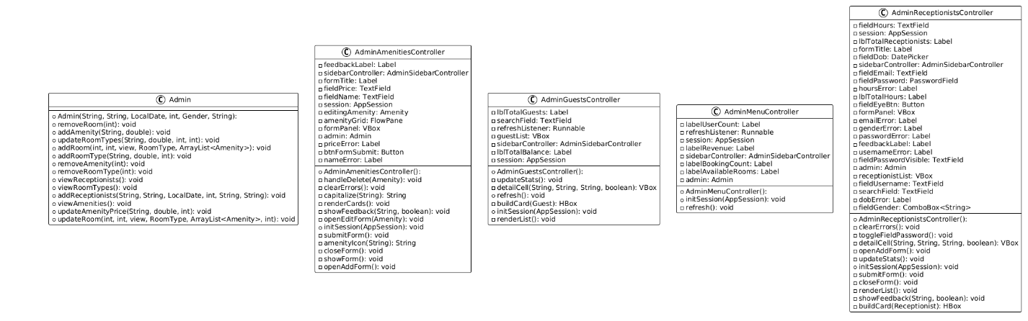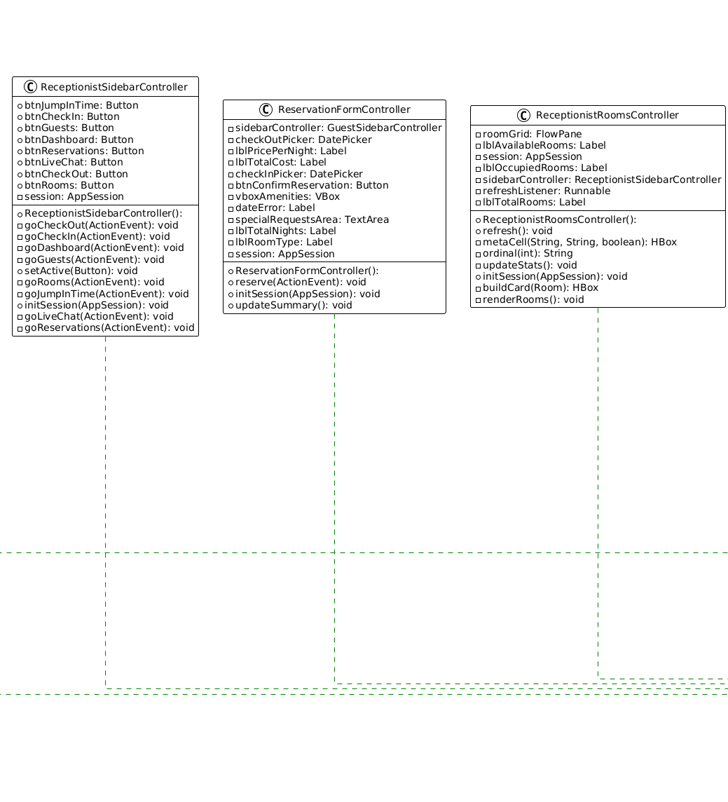

16.Links
Github Link
https://github.com/Seif-git2007/Hotel-Reservation-System.git
Youtube Video Link
https://youtu.be/FcQh77Qml70?si=qqLxEXjaW12PwfmO

